JUnit-Set up Eclipse

Unzip the zip file downloaded from the link above.

Click the File Menu and then select the New -> Project... Menu

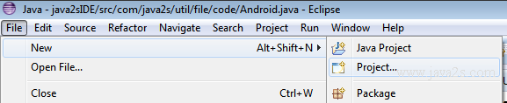

Select 'Java Project from Existing Ant Buildfile', Click next button

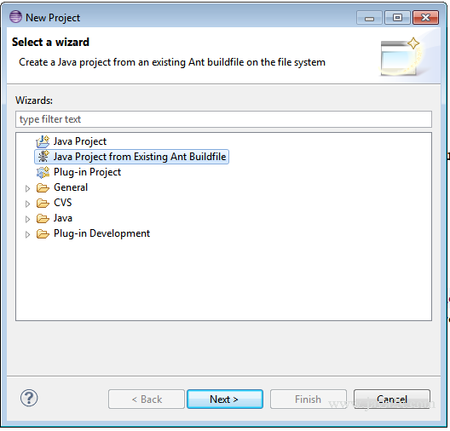

Click the Browse... button and select the ant build.xml file in the unzipped folder.

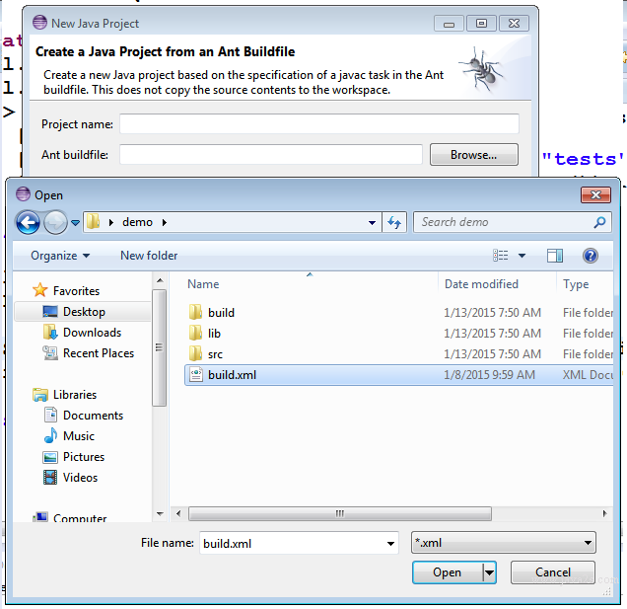

Verify the project information and click Finish Button

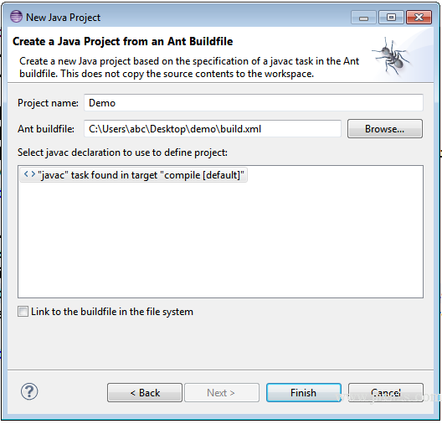

Project loaded in Eclipse

